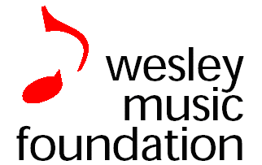
Wesley Music Scholarships 2019

APPLICATION FORM

WMC Application 310119
ABN 71 567 791 250
20-22 National Circuit, Forrest, ACT
Phone 02 6232 7248
wesleymc@musicwesleycanberra.org.au
www.wesleycanberra.org.au/music

All sections to be completed electronically and returned via email. Where not applicable, please insert “N/A”

Section 1 – Applicant Details
Surname: Click here to enter text. First Name: Click here to enter text.
Address: Address 1: Click here to enter text.
Address 2: Click here to enter text.
City: Click here to enter text.State: Choose an item. Postcode: Click here to enter text.

Phones: (H) Click here to enter text.
(M) Click here to enter text.
Email: Click here to enter text.
Student ID#: Click here to enter text.
Date of Birth: Click here to enter text.

Section 2 – Musical Experience
Instrument/Voice Type: Click here to enter text.
Teacher(s): Click here to enter text.
Courses and Exams undertaken and Grades:

Experience, including main performances and repertoire:

Any Scholarships, awards, prizes or grants received:

Other Relevant Achievements:

Longer term musical goals and interests:

Estimate your sight-reading ability: Choose an item.

Names and contact details (phone numbers) for at least two referees:
- Click here to enter text.
- Click here to enter text.
- Click here to enter text.

Are you available in the week beginning Monday, 11th March? Choose an item.
If you are not available, we will contact you to arrange a convenient time/day.

Date: Click here to enter a date.

Additional relevant information has been attached: ☐

If you are under 18yrs, please ask one of your parents to supply a short statement (email) saying that they support your application for a Scholarship

Applications for scholarships on this form should be forwarded by email only to Liz McKenzie at lizm@music.wesleycanberra.org.au

